# **Multi Thread Download Files from FTP/SPTP - Automation**

By-Youvendra

***Objective:*** This document shows how to setup the automation which has capability to download files (all type) in multithread from FTP/SFTP location.

***Technology used:*** PowerShell, Batch, Any task schedular tool.

***Implementation Steps:***

1. Here we are making use of 3rd party software(WinSCP) to download the files from SFTP so we should have winscp software installed in our system.
2. Defining variables which stores SFTP locations, file local directory, file remote directory etc in the 1st part of the application.

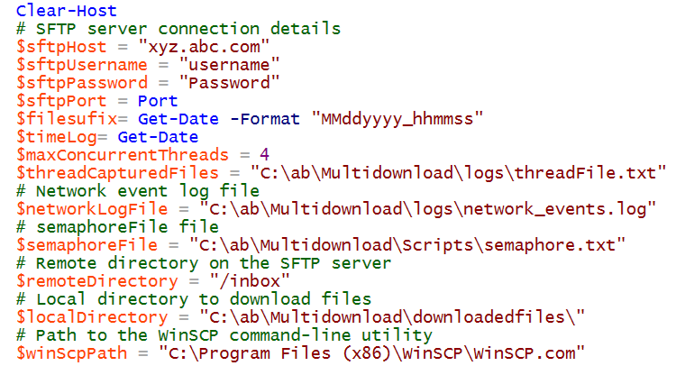

1. 2nd part of the script consist of all the functions which used to capture logs, test running threads etc.

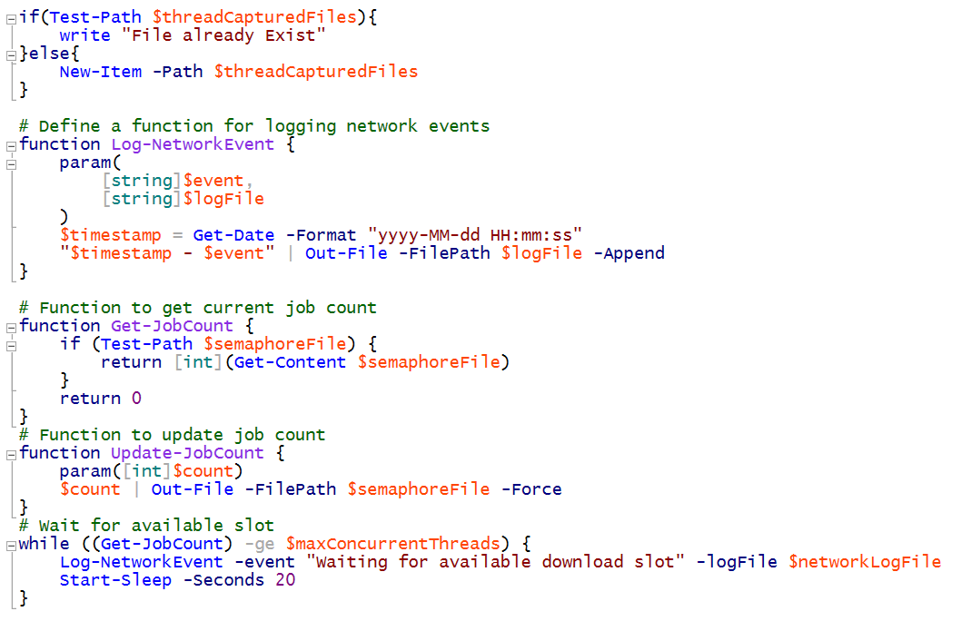

1. In 3rd section we are listing and filtering the files using regular expression. [FYI- we can find host key in winscp]

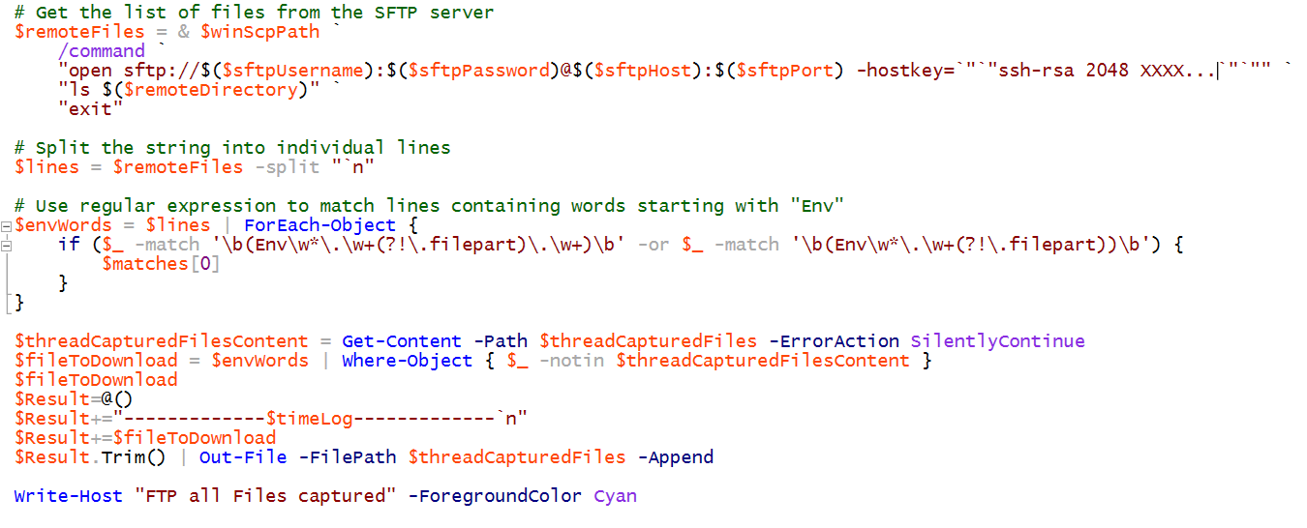

1. Now this is the main block of code which download files from SFTP.

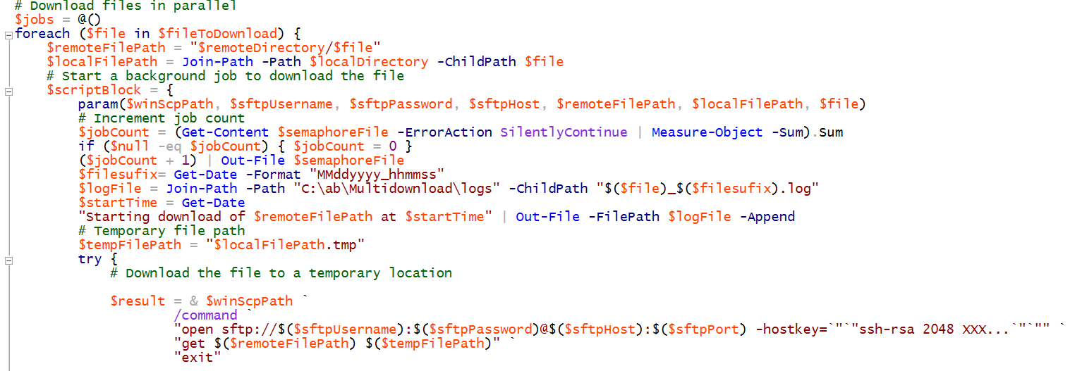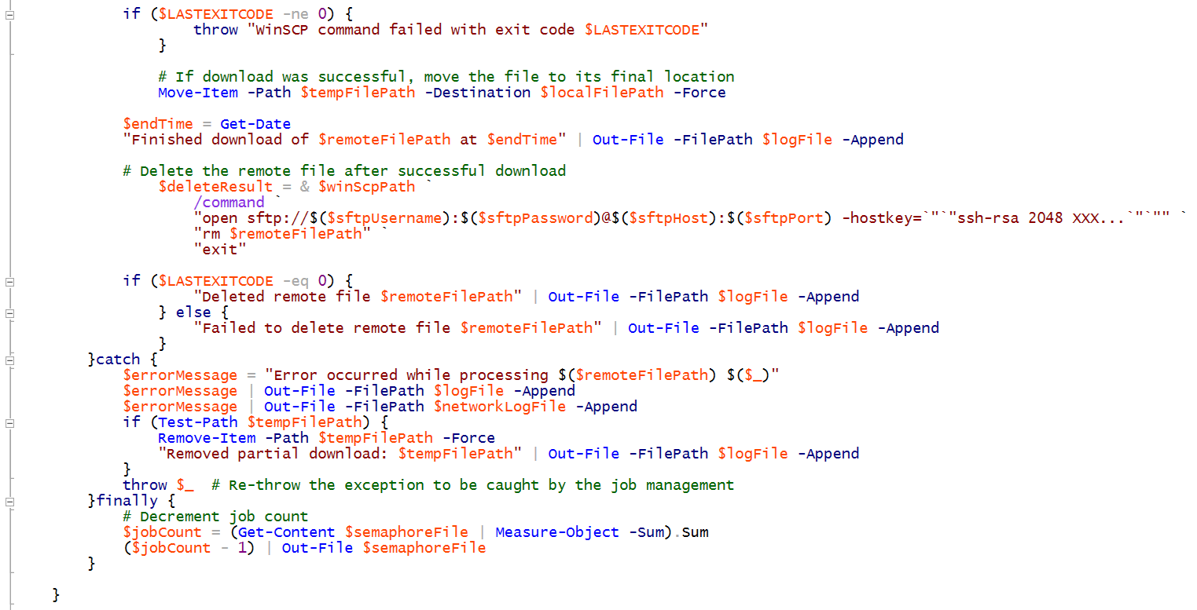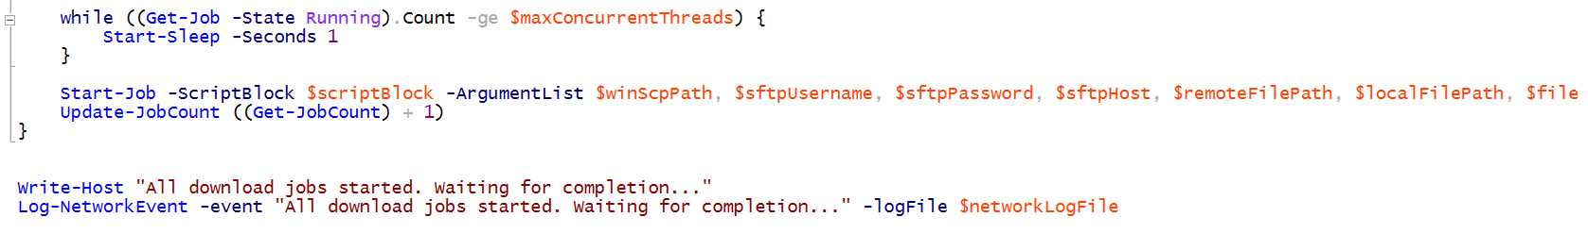

1. Now 5th block has code which help to check whether all threads completed.

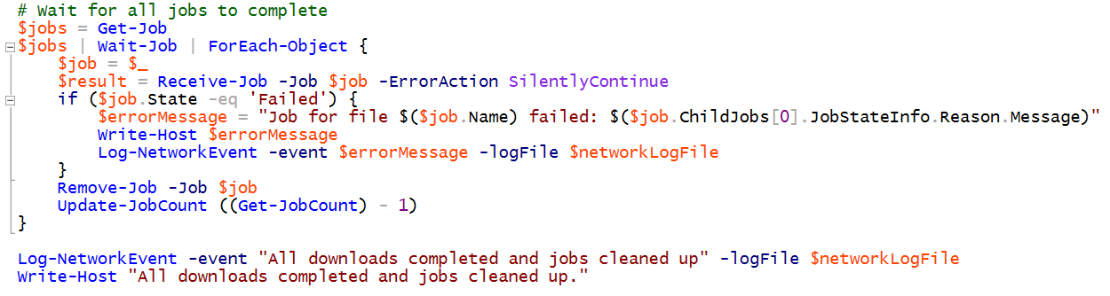

1. This section is not compulsory but its good to have it. It create the consolidated log file.

